What is Refection & Renewal? (aka Formation)

The educational vocation is one that requires renewal of mind, heart & spirit. Two primary sources for this renewal are the inner teacher who speaks in solitude, and the community of fellow educators. Formation is the process of creating a quiet and focused space that allows the voice of the inner teacher to be heard. Formation invites educators to reclaim wholeness & vocational clarity and makes connections between renewal of their own spirit and the revitalization of education.

Formation (R & R) in the Community Colleges is both an individual and professional endeavor that involves:

recognizing that we are all engaged in teaching, learning, leading and
serving, no matter the job title, thus expanding our understanding of the
truth that “We Teach Who We Are.”

nurturing identity and integrity, identifying and honoring gifts

acknowledging the lifelong process of unfolding, honoring the unique
journey of each individual

providing the opportunity to consider important questions about life and
who we are which may be rarely asked or considered

understanding that while exploration of one’s “inner teacher” is a personal
experience, it need not be entirely private, and can often be facilitated through
community

Activities to facilitate Refection & Renewal may include:

-Book Groups

-Retreats

-Semester Series Sessions

“Formation is journeying, individually and in community to identify our true selves and our deep integrity. From this center proceeds our action.”
Parker Palmer

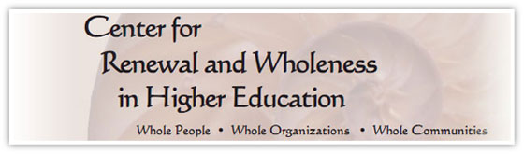
http://www.richlandcollege.edu/crwhe/

